**TITLE**

EXPERT SYSTEM - DIAGNOSE A MECHANICAL PROBLEM

**MEMBERS**

RONNY MORÁN

GUSTAVO LONDA

RENATO ILLESCAS

**GROUP NUMBER**

#2

**DEFINITION OF THE PROBLEM**

Diagnose mechanical faults in cars, based on an immediate response, which allows inexperienced users and experts to accurately determine problems such as gearbox, fuel heating, car vibration, ignition delay, etc., maintenance report: tires, oil change, brake fluid, coolants, tuning, alignment and balance, spark plugs, alternator, radiator.

**A GENERAL FEASIBILITY ANALYSIS, DESCRIBING IF IT IS JUSTIFIED, POSSSIBLE ANDR APPROPIATE TO DEVELOP THE PROJECT USING AI TECNHIQUES**

**Operational Feasibility**

Our expert system is a desktop application with friendly user interface of easy handling and free access, users will be able to select different problems / faults of their cars, to obtain the diagnosis / recommendation of the car.

The feasibility of the project is high because the extraction or knowledge base can be obtained from experts of the Faculty Engineering in Mechanics and Production Sciences at ESPOL and others interested in the project that wish to contribute with experience in this field. Three students of the career of Engineering in Computational Sciences of the same university, Escuela Superior Politécnica del Litoral. They'll  develop the expert system.

**Technical feasibility**

Currently we’ve 3 computers with Windows 8 System for development of the expert system, the characteristics computers are:

Brand: DELL

Memory: 8GB

Hard Disk: 1 TB

Processor: Intel Core i7 2.2 GHz

This expert system to be developed doesn’t generate conclusions based on common sense. There are tools (shells) to facilitate development expert systems, among the available shells consist PROLOG, JESS, CLIPS software that use the inference rules if..then are open license, we’ve the knowledge mechanical experts; For which the development of the expert system is possible.

We justify development our system because the mechanical experts are needed in several places for diagnose faults in cars in addition the system contributes with a high value and reliable diagnosis.

In conclusion, it’s feasible to develop using AI because of the high content input data and rules processing the problem diagnosis help to reduce human error, because the software works much more efficiently and margin of error decreases.

**ACQUISITION OF PRELIMINARY KNOWLEDGE NEEDED TO SOLVE THE PROBLEM**

The experts were identified by recommendation, which they contributed with the knowledge.

There are differents ways of representing knowledge; so in our shell we will represent this knowledge as production rules (rules IF - THEN).

We investigate the components an expert system (user interface subsystem, explanation subsystem, inference engine, administration system with the knowledge base, knowledge acquisition subsystem) that differentiate it from conventional systems.

Through the cycle development to expert systems we analyzed and selected development tool (shell) that contains components for our expert system and allows us access to the Java programming language.

|  |
| --- |
| https://lh4.googleusercontent.com/iXHvdTAwEFuDctfhdgh-4DFz58N-xl3nCm9MsKs2K7NkEPZ89WWn-U1VCudTt90lk2vSzyQMTZolK-DUtOxESPTz0M4FDYLhOOWCp8ZVne0kAwcr6Ul7dtn1IzBw3k0bxnCMAdCT |
| System Objects |
|  |

**STAGE**

|  |  |
| --- | --- |
| Case IA-001 |  |
| Use Case Name | Load system. |
| Actors | User |
| Event Flow | Enter diagnosis |
| Conditions entry | The user selects type the car, mechanical or automatic |

|  |  |
| --- | --- |
| Stage name | Access to system Auto mechanic |
| Participating actors | User |
| Event Flow | Fault selection presented.  Generate Results |

|  |  |
| --- | --- |
| Stage name | Access to system Auto automatic |
| Participating actors | User. |
| Events Flow | Fault selection presented.  Generate Results |

|  |  |
| --- | --- |
| Stage name | Exit |
| Participating actors | User. |
| Events Flow | * Chose exit button |

**DIAGRAM SEQUENCE**

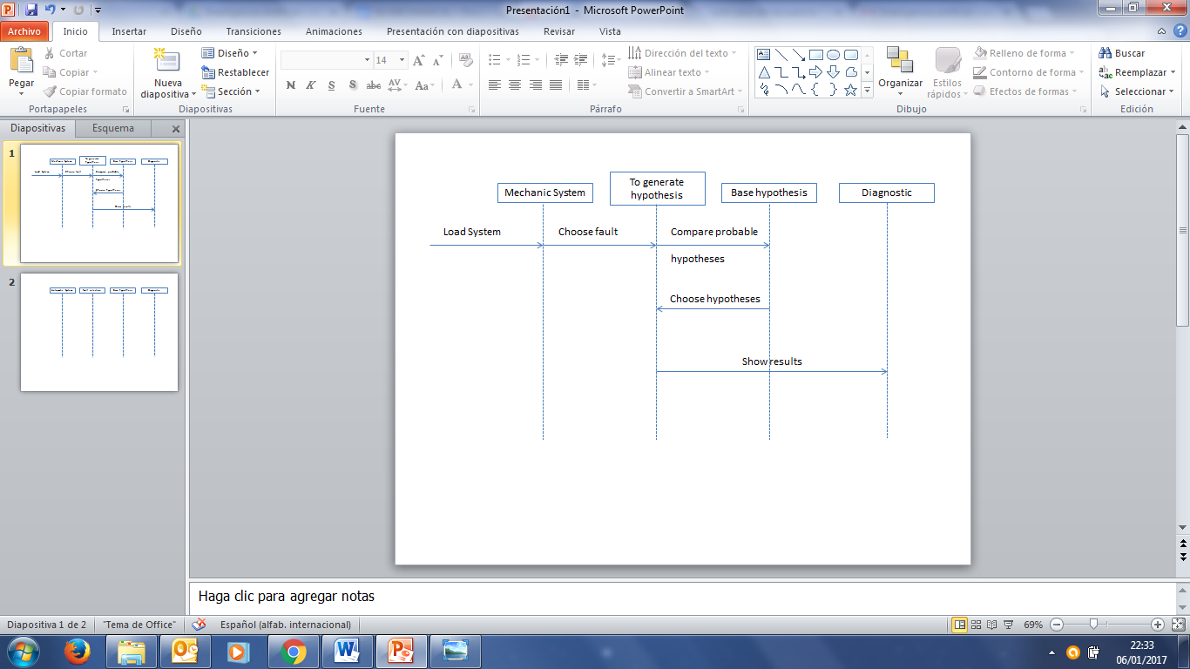

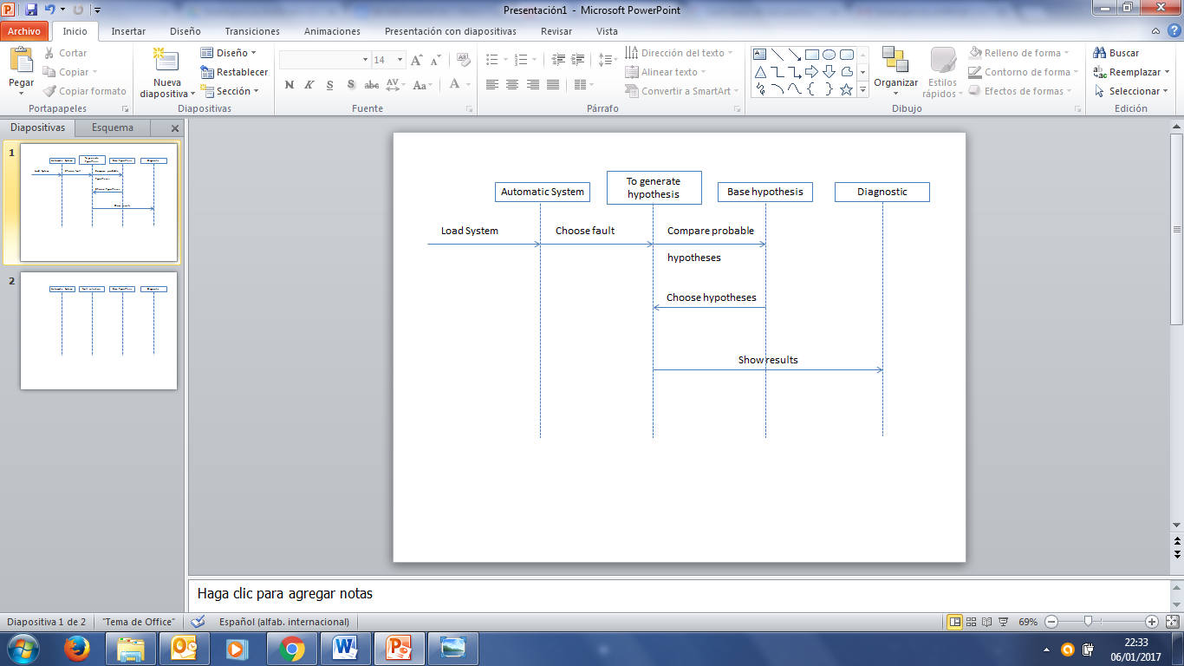

**A DESCRIPTION OF THE PROBLEM PROPOSED TO BE SOLVED, USING AI TECHNIQUES**

An Expert System (Intelligent System) quickly displays the fault diagnosis a motor vehicle.

We use the Knowledge of the experts that will be stored in the Knowledge Base shell component represented by IF - THEN rules.

The data base contains facts, the problem in the moment to input information in the expert system. The Control Structure as Reasoning Methods is through Inference Rules this rules will be triggered by Data driven (Forward chaining) and the control strategies to process this rules will be through the less orden and the secuency orden of rules is from top to bottom.

**REFERENCES**

[1] Covarrubias, R. F., & Covarrubias, A. G. F. (2013). Desarrollo de un sistema experto para el diagnóstico de fallas automotrices. *TE & ET: Revista Iberoamericana de Tecnología en Educación y Educación en Tecnología*, (11), 83-91.

[2] Giarratano, J., & Riley, G. (2001). *Sistemas expertos: principios y programación*. International Thomson.